Write XSL stylesheet to transform the following XML document to display is as figure 1.

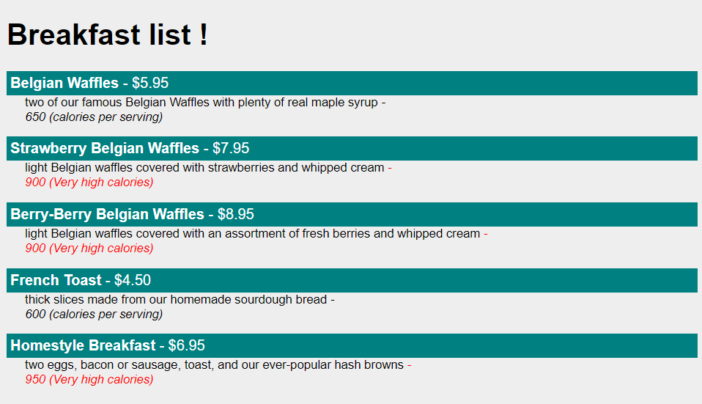

Figure

<?xml version=**"1.0"** encoding=**"UTF-8"**?>

<?xml-stylesheet type=**"text/xml"** href=**"sample.xsl"**?>

<breakfast_menu>

<food>

<name>**Belgian Waffles**</name>

<price>**$5.95**</price>

<description>**two of our famous Belgian Waffles with plenty of real maple syrup**</description>

<calories>**650**</calories>

</food>

<food>

<name>**Strawberry Belgian Waffles**</name>

<price>**$7.95**</price>

<description>**light Belgian waffles covered with strawberries and whipped cream**</description>

<calories>**900**</calories>

</food>

<food>

<name>**Berry-Berry Belgian Waffles**</name>

<price>**$8.95**</price>

<description>**light Belgian waffles covered with an assortment of fresh berries and whipped cream**</description>

<calories>**900**</calories>

</food>

<food>

<name>**French Toast**</name>

<price>**$4.50**</price>

<description>**thick slices made from our homemade sourdough bread**</description>

<calories>**600**</calories>

</food>

<food>

<name>**Homestyle Breakfast**</name>

<price>**$6.95**</price>

<description>**two eggs, bacon or sausage, toast, and our ever-popular hash browns**</description>

<calories>**950**</calories>

</food>

</breakfast_menu>